1 Schooner Lane,

Milford, Connecticut

**2,400 Sq. Ft., plus 1,500 Sq. Ft. Outdoor Patio Area**

Max Occupancy:

* 140 People total inside
* 120 People outside on patio
* Harbor views
* Boat slips available
* Walk to downtown
* Established night life
* 300+ apartments in building portfolio

Call for details!

Contact: Scott Zakos

Direct: 203-226-7101 ext. 4

Email: scott@vidalwettenstein.com

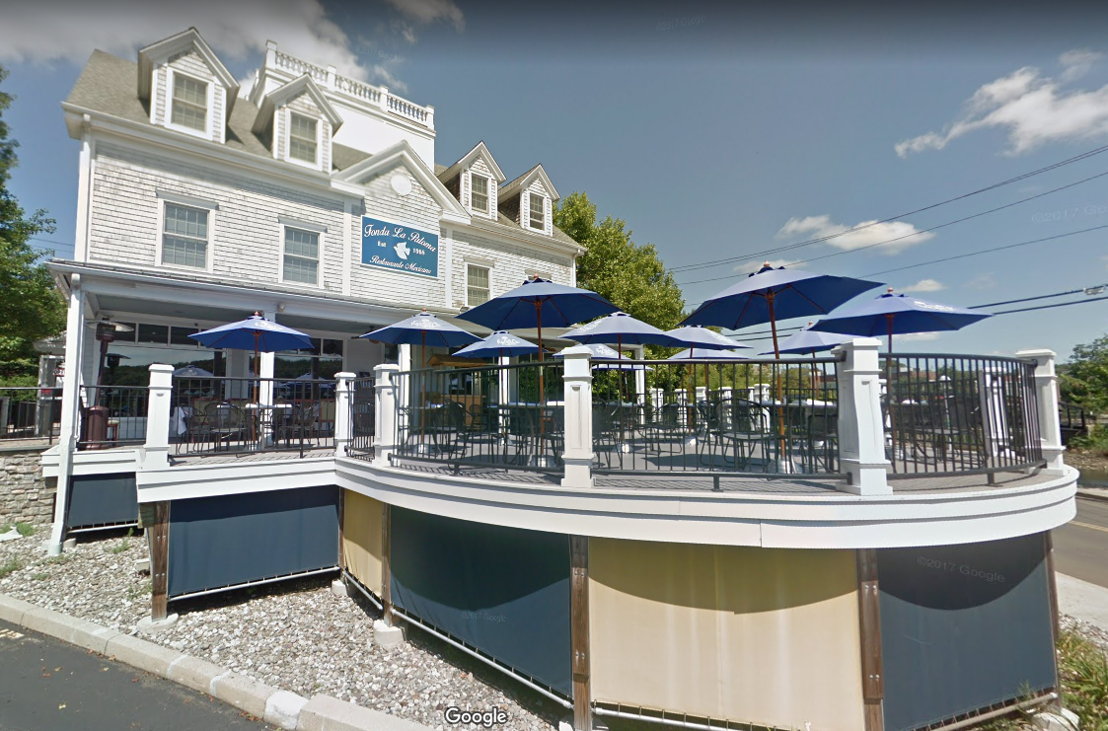

SHORELINE RESTAURANT OPPORTUNITY

Individual Members

Society of Industrial and Office Realtors

719 Post Road East, Westport, CT 06880

www.vidalwettenstein.com

All information from sources deemed reliable and is submitted subject to errors, omissions, change of price, rental, and property sale and withdrawal notice.

standard-vertical

White logo